Hebridean sheep society
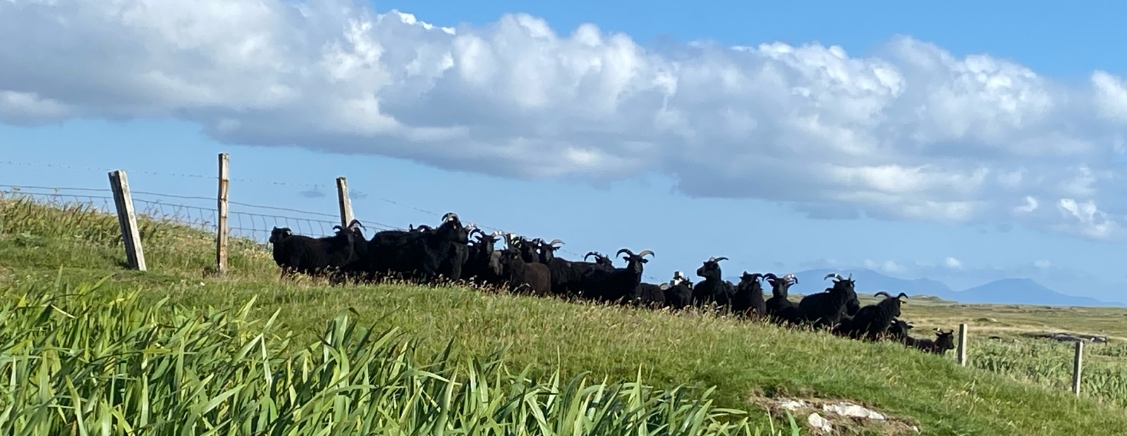
Summer Symposium 2025
Isle of North Uist
Booking Form

I wish to make a booking for this Symposium

Name
Email address
Tel No
Number in Party
Please indicate below any dietary requirements for any member of your party for Friday lunch
Does your party want to book for the buffet dinner at Langass Lodge?
Please indicate below any dietary requirements for any member of your party for the buffet dinner

Payment

Number of attendees @ £15 each |  | Total Cost | £
Number of attendees for Buffet Dinner @£35 each |  | Total Cost | £
Total Payable |  |  | £

Make payment to : Hebridean Sheep Society
40-52-40
00027345
Please include the Reference : Symp25

Make Payment, and send this form to eric.medway@hebrideansheep.org.uk by 31 July.

